**LAB AUTOMATION USING IOT**

**A PROJECT REPORT ON**

*Submitted By*

*VARUN U*

*ZUBAIR*

*BHARATH M*

*SURENDRA R.G*

*In partial fulfillment for the award of the diploma*

*in*



**Diploma in Computer Science and Engineering**

Of

DEPARTMENT OF COMPUTER SCIENCE AND ENGINEERING

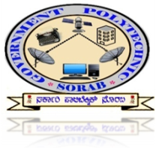

**GOVERNMENT POLYTECHNIC, SORAB**

**DEPARTMENT OF TECHNICAL EDUCATION**

**BENGALURU-560 001**

Year of submission: April-2020